**To rename the Existing VM**

1. First, we need to take the snapshot of the OS Disk for safer side.
2. Delete only VM and **keep NIC,VNET/Subnet, Data Disk, OSDisk**, note down the **private IP** but before decom the server , backup must be disable and removed.

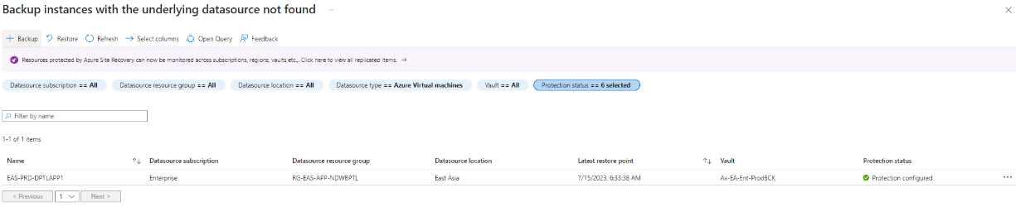

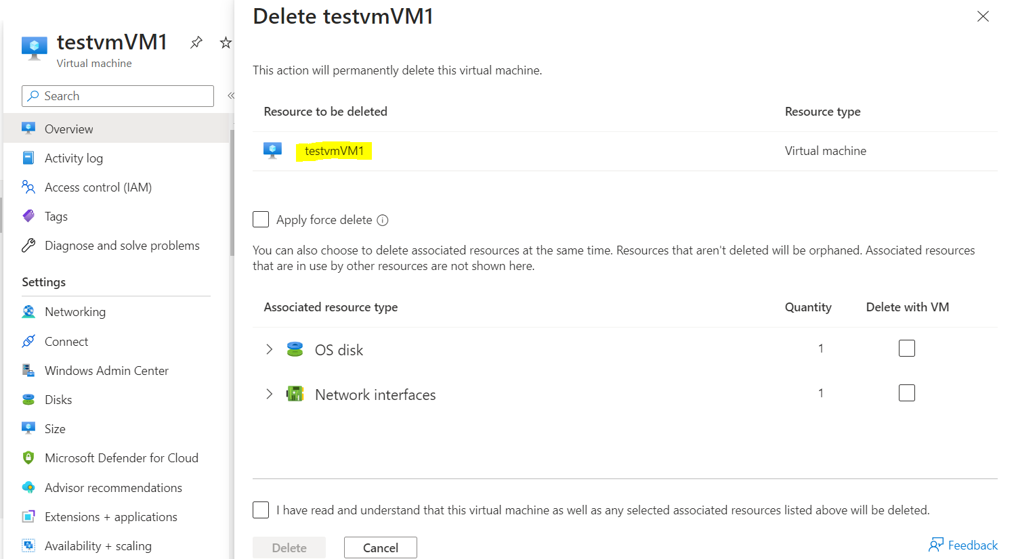

1. Then from Current existing OS Disk in the same RG, same VNET/Subnet, Create new VM with recommended Name.

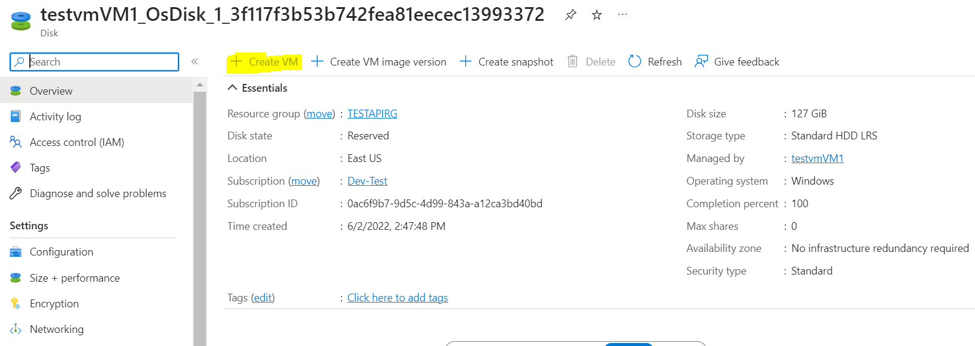

1. Once VM creation will be done, shutdown the vm and attached the existing NIC and detached the new NIC and up the server again.

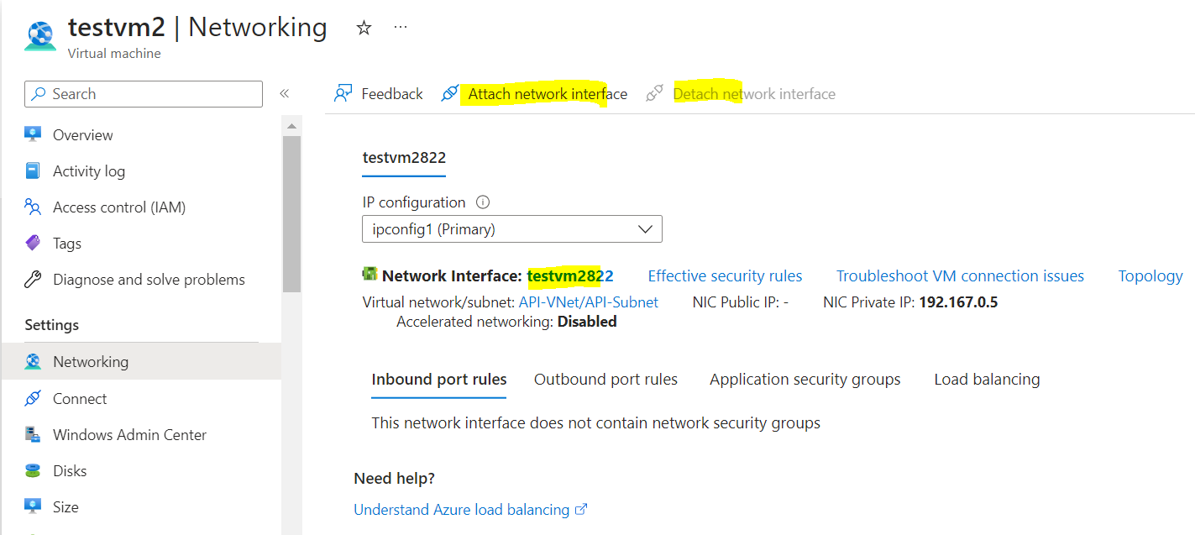

1. Then Attach the Existing data Disk.
2. Validate the Private IP, try RDP and confirm hostname.
3. Delete the existing VM backup from the restore point to save storage cost.

